Preschool News & Notes

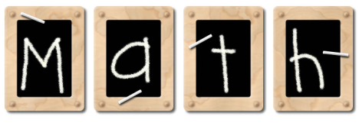
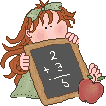
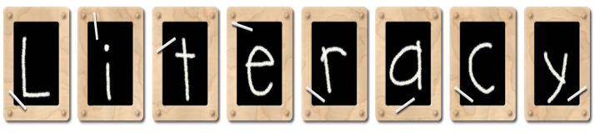
Viking Elementary – Mrs. Durkee – 523-4425 – April 20, 2018

Graphics created by: Graphic Garden and Lettering Delights

We worked with shapes, combining, flipping and turning them. We also put the correct number of fruits on our trees to match a numeral between 1 & 20. We practiced identifying the number that comes before and after a number between 10 and 20.
Letter of the Week: K for Miss K, Karlee, Kinley
Kaosidy and Kora, k for kite, kangaroo, kind

We are working on alliteration-identifying things that begin with the sound of a certain letter. We worked on b, s, and t. We read another Eric Carle book, Little Cloud and made cloud pictures using our imaginations to decide what our clouds look like.

Email: jdurkee@mccfreeze.org

We have sure enjoyed having Miss K in our
room this month! Today is her last day, and
we will miss her. Best wishes, Miss K! April 23, 24, 26 P/T Conferences
If you can’t make your time, please let
We talked about Earth Day and me know by Monday. Thanks!
Monday, January 25th Preschool screening

some of the things we can do to
help take care of our world.

Pete the Cat had a great visit with Joshua. He went home for the week with Josie.
Our Star of the Week was Maverick. Next week will be Luke.

We learned about different kinds of trees and drew our favorite tree. Vocab: deciduous, coniferous ( I know those are big words, but kids like the challenge of saying new, unfamiliar words).

We’re moving into warmer weather, and we hope by next week our playground will be dry enough to play on without snow pants and boots—hurray!

