Preschool News & Notes

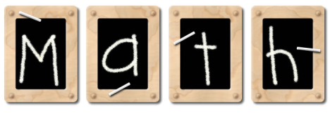
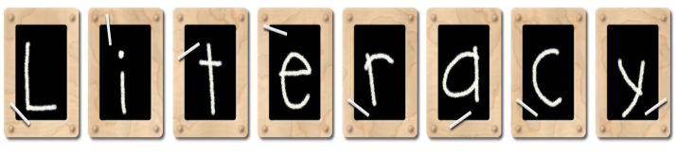
Viking Elementary – Mrs. Durkee – 523-4425 –

Graphics created by: Graphic Garden and Lettering Delights

We practiced writing the numeral 18; we collected 6 groups of 3 objects and introduced counting by 3’s.

We identified larger numerals in Number Bingo.

Letter of the Week: Yy in yes, yogurt, yoyo,
yarn

We discussed what animals live in trees. We also shared our ideas and read about what trees are used for.

We practiced saying a few Spanish words: como estas’ (how are you?) and arbol (tree) from a book called Pablo’s Tree.

Email: jdurkee@mccfreeze.org

Science: Out of all our seeds, only one Only 5 days of preschool left! Please note these dates:
sprouted! We talked about why (probably too 5/11 Farm Field Trip with picnic (school sack lunch)
cold). We threw away the rotten, moldy seeds 5/17 Program/Graduation at 1:30 p.m.
And set up a new experiment in our mini green Also last day of SR!
houses. Please help your child find a warm,
sunny spot to hang the greenhouse so that
(s)he can try again.

Monday, January 25th Preschool screening

Pete the Cat had a great time with Josie Ombler! He has made the rounds to all your homes and had a wonderful time. Thanks for participating!

Star of the Week: Luke Bring Next week: Kora Loe

