Preschool News & Notes

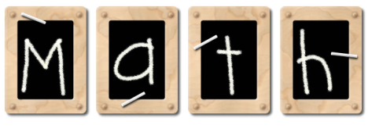
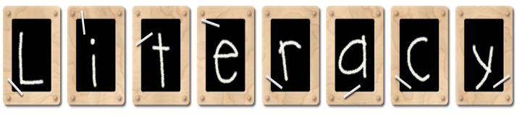
Viking Elementary – Mrs. Durkee – 523-4425 – April 6, 2018

Graphics created by: Graphic Garden and Lettering Delights

We practiced writing the numeral 16. Please practice with your child counting objects to 30.
Ms. K helped center groups practice identifying items removed from view and work on comparison problems this week.
Letter of the Week: Ee in Emmett, elephant,
echo,egg
We need practice identifying words that have the same beginning sound. We are doing great with rhyming words!

We read The Little Red Hen and talked about being helpers at home and at school.

Email: jdurkee@mccfreeze.org

I will be attending a conference next week;
We have begun a unit on Trees and plants. We
have set up an experiment to sprout lima bean I will be attending a conference next week.
seeds. Please help us watch for signs of Spring! Sheree Setterholm is my sub and Ms. K will
be teaching some as well. If you have bus changes, etc. please send a note or call the office.
Monday, January 25th Preschool screening

school

Our Star of the Week was Parker Donarski.
Kora Loe April 8
Parker Donarski April 9
Next week will be Maverick Peters.

Pete the Cat had a blast with Kaosidy Mugaas!
He will spend the week with Jack Wawrzyniak.

